Analyzing the Impact of COVID-19 on

Mobility Patterns

Santhosh Kumar Suresh Kumar  
santhoshkumarsures@lewisu.edu  
DATA-53000, Fall 2024

Data Visualization Lewis University

# Introduction

The COVID-19 pandemic has dramatically altered global mobility patterns, affecting daily commuting and travel behaviors across various sectors. This project aims to provide a comprehensive analysis of how the pandemic has influenced mobility, using data from two key sources. The first source, Google's COVID-19 Community Mobility Reports [1], offers detailed insights into changes in movement across different categories such as retail, recreation, groceries, parks, transit stations, workplaces, and residential areas within the United States. These reports highlight how public health measures and lockdowns have impacted people’s movements, covering trends over the years 2020, 2021, and 2022, and showing percentage changes compared to the baseline. Additionally, the Globalization and Mobility for Tourism dataset from Kaggle [2], spanning the years 1995 to 2021, provides context on international travel trends and the broader implications for the tourism industry. By analyzing these datasets, this project seeks to visualize and understand the shifts in mobility patterns due to the pandemic, shedding light on the profound and lasting impacts on daily life and global travel behaviors. The findings will help illustrate the extent to which COVID-19 has reshaped how and where people move

# Data Description

The COVID-19 Community Mobility Reports [1] provide insights into how visits and lengths of stay at various places changed compared to a baseline value, using aggregated and anonymized data similar to Google Maps' popular times feature. These changes are measured as percentage deviations from the median values during the 5-week period from January 3 to February 6, 2020, and cover trends over the years 2020, 2021, and 2022. Additionally, the Globalization and Mobility for Tourism dataset from Kaggle [2] spans the years 1995 to 2021 and offers comprehensive data on international travel trends, economic impacts of mobility restrictions, and various metrics related to travel behaviors and tourism sector performance. Together, these datasets offer a detailed view of how COVID-19 has influenced mobility and travel patterns, highlighting significant changes in daily life and global travel behaviors.

Table I below lists the ten key attributes that highlight the analysis of mobility changes due to COVID-19. These attributes provide a comprehensive overview of how mobility patterns were affected by the pandemic, offering valuable insights into the trends and behaviors observed during this period.

1. Data Attributes

| **Attribute** | **Type** | **Example Value** | **Description** |
| --- | --- | --- | --- |
| Date | Categorical | 01/01/2023 | Date of the data collection or the date the event occurred |
| Country | Categorical | USA | The name of the country |
| retail_and_recreation_percent_change_from_baseline | Numeric | 5 | 5 percent above the baseline |
| grocery_and_pharmacy_percent_change_from_baseline | Numeric | 10 | 10 percent above the baseline |
| parks_percent_change_from_baseline | Numeric | -19 | 19 percent below the baseline |
| transit_stations_percent_change_from_baseline | Numeric | -21 | 21 percent below the baseline |
| workplaces_percent_change_from_baseline | Numeric | 5 | 5 percent above the baseline |
| residential_percent_change_from_baseline | Numeric | -24 | 24 percent below the base line |
| International tourist arrivals by region | Numeric | 10000 | Totoal number of people visited |
| Region | Categorical | Europe | Tourist visiting regions |

# Methodology and results

For this project, data was collected from two primary sources: Google's COVID-19 Community Mobility Reports [1], which provide percentage changes in mobility across various categories compared to a baseline from January 3 to February 6, 2020, covering the years 2020, 2021, and 2022, and the Globalization and Mobility for Tourism dataset from Kaggle [2], spanning from 1995 to 2021. The analysis began with exploratory data analysis (EDA) to understand trends and patterns within the datasets. This was followed by a category-wise analysis of the Google mobility data, comparing the percentage changes in mobility for different categories over the specified years. Comparative analysis was also conducted to assess the differential impact of COVID-19 on various sectors. The tourism data analysis involved examining international travel trends and economic impacts over time. The findings were then visualized and reported, highlighting the impact of COVID-19 on mobility patterns and tourism, supported by comprehensive data visualizations.

In Fig.1,The image is a bar chart titled "Comparison of Monthly Averages of Grocery and Pharmacy Percent Change from Baseline (2020 vs 2021 vs 2022)," displaying data from January 2020 to November 2022, with the Y-axis showing average percent changes relative to the baseline median value from Jan 3 to Feb 6, 2020. The colors blue, orange, and green represent the years 2020, 2021, and 2022, respectively. The chart highlights significant fluctuations in grocery and pharmacy visits during 2020, notably in April and December, a consistent increase from May to December in 2021, and a slight decline in positive percent changes towards the end of 2022. This visualization provides insights into consumer behavior changes over three years, influenced by the COVID-19 pandemic, and demonstrates how visits to grocery and pharmacy locations fluctuated and gradually recovered over time.

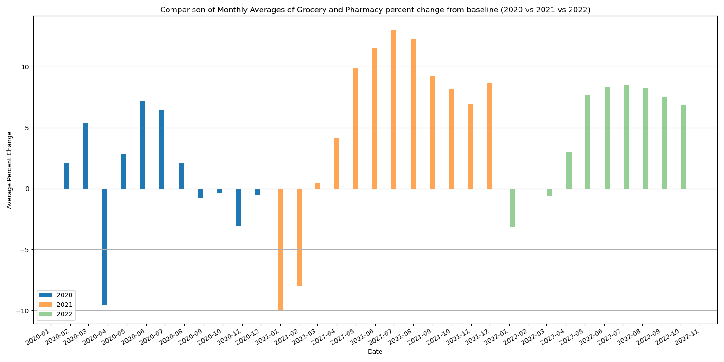Fig. 1 Comparison of Monthly Averages of Grocery and Pharmacy (2020 vs 2021 vs 2022)

In Fig. 2, The image is a bar chart titled "Comparison of Monthly Averages of Parks Visit percent change from baseline (2020 vs 2021 vs 2022)." The x-axis represents the dates from January 2020 to November 2022, while the y-axis shows the average percentage change in park visits compared to a baseline period (median value from Jan 3 to Feb 6, 2020). The chart uses blue for 2020, orange for 2021, and green for 2022. Key observations include a significant increase in park visits in 2020 starting in May, peaking in July, and then gradually decreasing towards the year's end. In 2021, park visits also rise starting in April, peaking in July, and decreasing towards December. Similarly, 2022 shows an increase starting in April, peaking in July, and declining towards November. This chart highlights seasonal trends in park visits over the three years, reflecting the impact of COVID-19 on park visit patterns

.

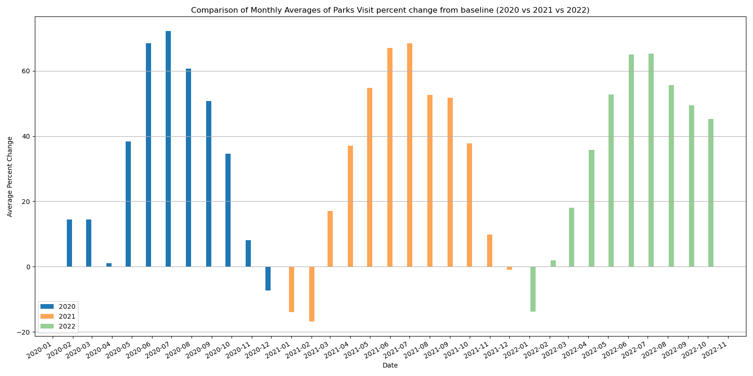

Fig. 2 Comparison of Monthly Averages of Parks Visit (2020 vs 2021 vs 2022)

In Fig. 3, The image is a bar chart titled "Comparison of Monthly Averages Residential Percent Change from Baseline (2020 vs 2021 vs 2022)." The x-axis represents the dates from January 2020 to November 2022, while the y-axis shows the average percentage change in residential metrics compared to a baseline (median value from Jan 3 to Feb 6, 2020). The bars are color-coded: blue for 2020, orange for 2021, and green for 2022. Significant fluctuations are observed, with notable peaks in April 2020 and January 2021. This chart provides insights into residential behavior changes over three years, reflecting how the COVID-19 pandemic influenced residential patterns and home stay durations.

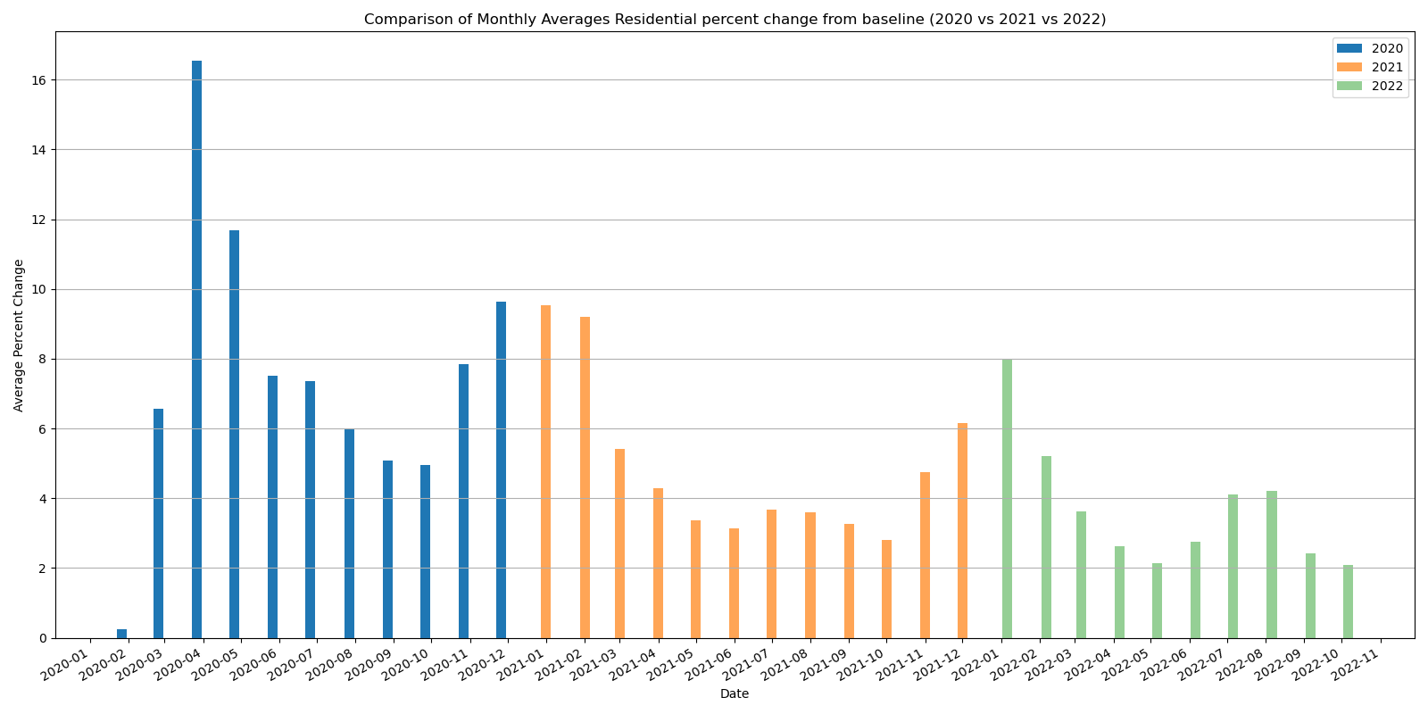

Fig. Fig.3 Comparison of Monthly Averages Residential Percent Change from Baseline (2020 vs 2021 vs 2022)

In Fig. 4, The image is a bar chart titled "Comparison of Monthly Averages of Retail and Recreation Percent Change from Baseline (2020 vs 2021 vs 2022)." The x-axis represents the date, ranging from January 2020 to November 2022, while the y-axis represents the average percent change. The chart uses three different colors to represent the years: blue for 2020, orange for 2021, and green for 2022. The chart shows the monthly average percent change in retail and recreation activities compared to a baseline. In 2020, there is a significant drop in percent change starting from March, reaching the lowest point in April, and then gradually improving but remaining negative for the rest of the year. In 2021, the percent change becomes positive starting from March and continues to rise, peaking around June and July, before stabilizing. In 2022, the percent change remains positive throughout the year, with some fluctuations but generally showing an upward trend. This chart visually represents the impact of the COVID-19 pandemic on retail and recreation activities over three years, showing the initial decline in 2020, recovery in 2021, and continued positive growth in 2022.

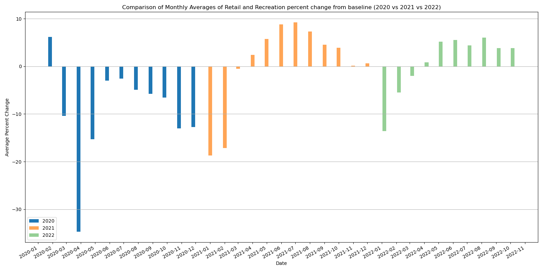

Fig. 4 Comparison of Monthly Averages of Retail and Recreation (2020 vs 2021 vs 2022)

In Fig.5, The image is a bar chart titled "Comparison of Monthly Averages Visits of Transit Stations percent change from baseline (2020 vs 2021 vs 2022)." The x-axis represents the date, ranging from January 2020 to November 2022, and the y-axis represents the average percent change. The chart uses three different colors to represent the years: blue for 2020, orange for 2021, and green for 2022. The bars show the percent change in visits to transit stations compared to a baseline. The chart indicates a significant drop in visits in 2020, especially in April, followed by gradual changes in 2021 and 2022, with some months showing positive changes in 2022. This chart visually represents the impact of events like the COVID-19 pandemic on public transit usage over three years.

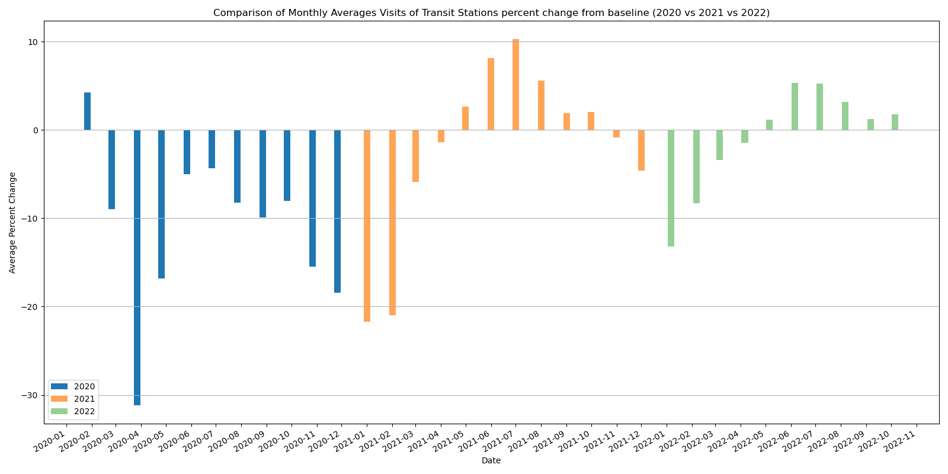

Fig.5 Comparison of Monthly Averages Visits of Transit Stations percent change from baseline (2020 vs 2021 vs 2022)

In Fig.6, The image is a bar chart titled "Comparison of Monthly Averages Workplace Percent Change from Baseline (2020 vs 2021 vs 2022)." The chart compares the average percent change in workplace attendance from a baseline for the years 2020, 2021, and 2022. The x-axis represents the date, ranging from January 2020 to November 2022, while the y-axis represents the average percent change. The bars are color-coded by year: blue for 2020, orange for 2021, and green for 2022. The chart shows a significant decrease in workplace attendance starting in March 2020, with varying levels of recovery and decline in the subsequent years. This data is relevant for understanding the impact of events such as the COVID-19 pandemic on workplace attendance over these years.

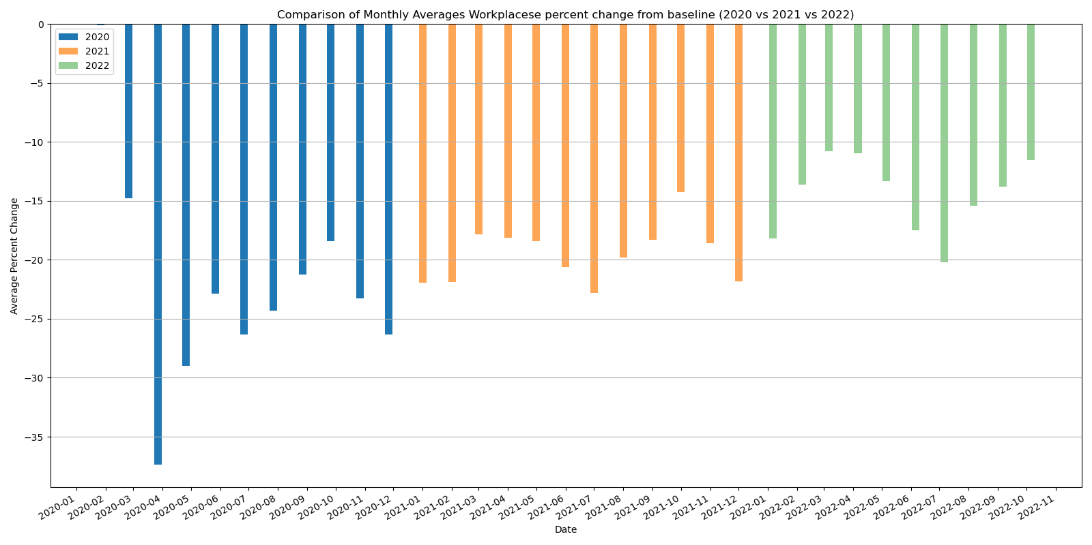

Fig.6 Comparison of Monthly Averages Workplace Percent Change from Baseline (2020 vs 2021 vs 2022)

In Fig.7, The line graph titled "Comparison of Retail & Recreation and Grocery & Pharmacy Percent Change (2020-2022)" illustrates the differences in mobility changes for these two categories over three years. Retail & Recreation (solid lines in blue for 2020, orange for 2021, and green for 2022) shows larger fluctuations with a significant drop in March-April 2020 due to initial lockdowns, followed by recovery in 2021 and continued positive growth in 2022. In contrast, Grocery & Pharmacy (dashed lines in red for 2020, purple for 2021, and brown for 2022) demonstrates more stability with less dramatic changes, reflecting consistent consumer needs for essential goods. Overall, the chart highlights the greater impact of COVID-19 on Retail & Recreation, while Grocery & Pharmacy remained relatively stable, underscoring the differential resilience and adaptability of these sectors to the pandemic's effects. This comparison effectively shows how the pandemic influenced different aspects of consumer behavior, with essential services maintaining more stability and discretionary activities experiencing greater volatility and recovery phases.

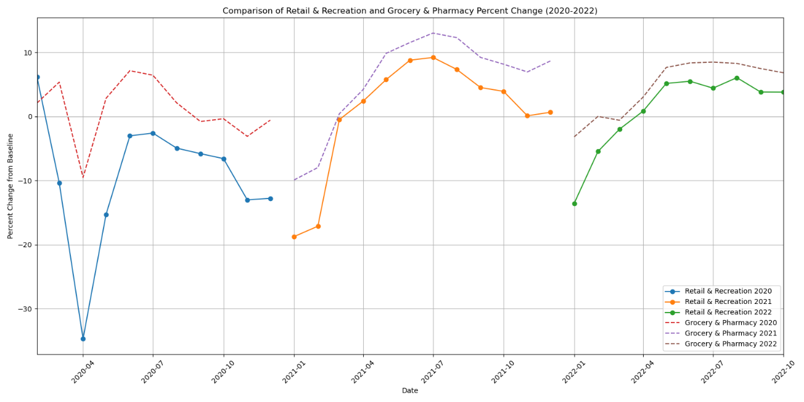

Fig.7 Comparison of Retail & Recreation and Grocery & Pharmacy Percent Change (2020-2022)

In Fig.8, The line graph titled "Comparison of Residential and Parks Percent Change (2020-2022)" contrasts the percent change from baseline for residential and parks categories over the period from 2020 to 2022. The x-axis represents the date, ranging from early 2020 to late 2022, and the y-axis represents the percent change from baseline, ranging from -20% to 80%. The lines indicate significant differences: Residential percent change (blue for 2020, orange for 2021, green for 2022) remains relatively stable across all three years with minor fluctuations, reflecting consistent patterns in residential stays as people spent more time at home. Conversely, Parks percent change (red for 2020, purple for 2021, brown for 2022) shows considerable peaks and valleys, particularly in 2020 and 2021, indicating large fluctuations in park visits, likely influenced by lockdowns and easing of restrictions. This comparison highlights the differing patterns of change in residential and park usage over the given period, with residential metrics remaining stable and park visits exhibiting significant variability in response to external factors like the COVID-19 pandemic.

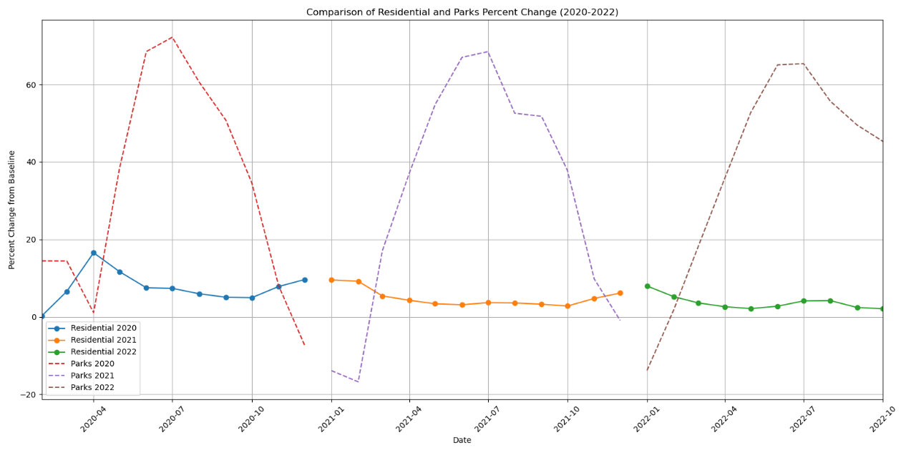

Fig.8 Comparison of Residential and Parks Percent Change (2020-2022)

In Fig.9, The line graph titled "Comparison of Residential and Workplaces Percent Change (2020-2022)" shows the percent change from baseline for residential and workplace locations from early 2020 to late 2022. The residential lines (solid: blue for 2020, orange for 2021, green for 2022) generally show an increase in percent change, indicating more time spent at home, especially during lockdown periods in 2020, with a stable trend in 2021 and 2022. In contrast, the workplace lines (dashed: red for 2020, purple for 2021, brown for 2022) show a significant decrease, reflecting the shift to remote work and reduced office attendance, with some recovery in 2022 but still below baseline levels. This comparison highlights the contrasting impacts of the COVID-19 pandemic, with increased home stays and decreased office visits over the three years.

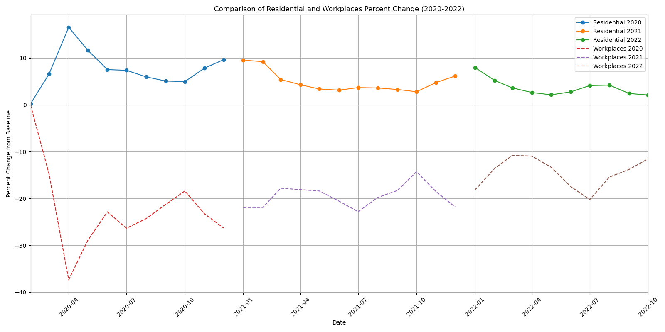

Fig.9 Comparison of Residential and Workplaces Percent Change (2020-2022)

In Fig.10, The line graph titled "Comparison of Residential and Workplaces Percent Change (2020-2022)" illustrates the percent change from baseline for residential and workplace locations from early 2020 to late 2022, using color-coded lines for each year. The residential lines show an increase in percent change, indicating more time spent at home, especially during lockdowns in 2020, with stable trends in 2021 and 2022. In contrast, the workplace lines show a significant decrease, reflecting the shift to remote work and reduced office attendance, with some recovery in 2022 but still below baseline levels. Both graphs highlight significant impacts of the COVID-19 pandemic on mobility patterns, with notable fluctuations in 2020 due to initial pandemic responses, followed by varying levels of recovery and stability in 2021 and 2022. They share similarities in structure and style, with consistent time frames and percentage changes, making them comparable and reflecting broader behavioral changes during the pandemic.

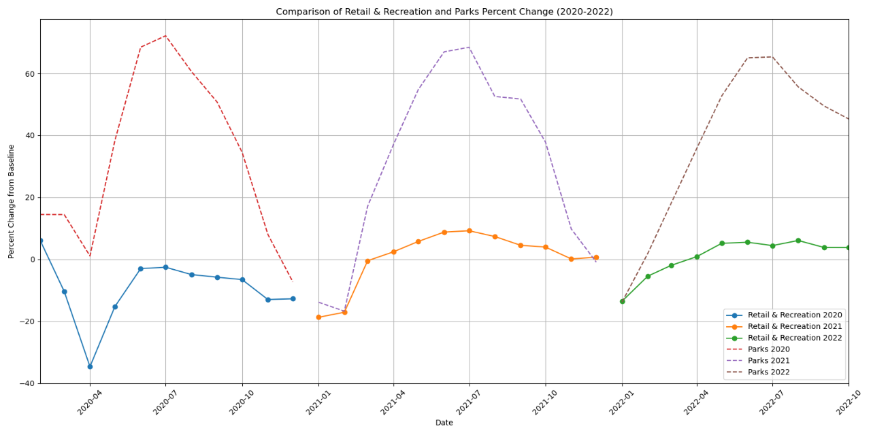

Fig.10 Comparison of Residential and Workplaces Percent Change (2020-2022)

InFig.11 The line graph titled "Comparison of Transit Stations and Retail & Recreation Percent Change (2020-2022)" compares the percent change from baseline for transit stations and retail & recreation from 2020 to 2022. Both sets of data reflect significant impacts due to the COVID-19 pandemic, with initial sharp declines in early 2020. Transit stations (solid lines: blue for 2020, orange for 2021, and green for 2022) experienced a steep drop around March-April 2020, with gradual recovery trends visible in 2021 and 2022, showing increased usage but still fluctuating. Retail & recreation (dashed lines: red for 2020, purple for 2021, and brown for 2022) also saw a major drop during the same period, followed by a recovery pattern. By 2022, both categories show positive percent changes, indicating a recovery from the initial disruptions. The overall trends in both graphs highlight how mobility patterns have been affected over time, with both sectors initially experiencing significant declines but showing recovery as restrictions eased and normal activities resumed.

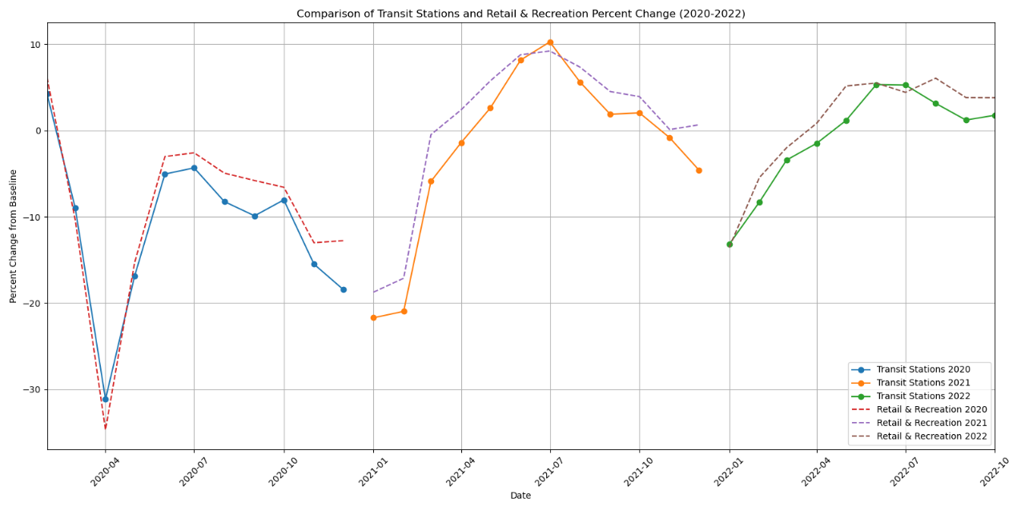

Fig.11 Comparison of Transit Stations and Retail & Recreation Percent Change (2020-2022)

In Fig.12, The graph titled "International Tourist Arrivals by Region (1995-2021)" displays the number of international tourist arrivals in various regions over the years. The y-axis represents the number of arrivals in units of 100 million, while the x-axis shows the years from 1995 to 2021. Regions are color-coded: Europe (red) consistently has the highest arrivals, peaking in 2019 before a sharp decline in 2020 due to COVID-19. East Asia and the Pacific (green) show steady growth, also peaking in 2019 before dropping in 2020. The Americas (orange) exhibit moderate increases with a similar 2020 decline. Africa (blue), the Middle East (purple), and South Asia (pink) have lower but increasing numbers until 2020, and 'Not classified' (brown) remains low and stable throughout. This graph underscores the pandemic's significant impact on global travel, reflecting broader trends in international tourism.

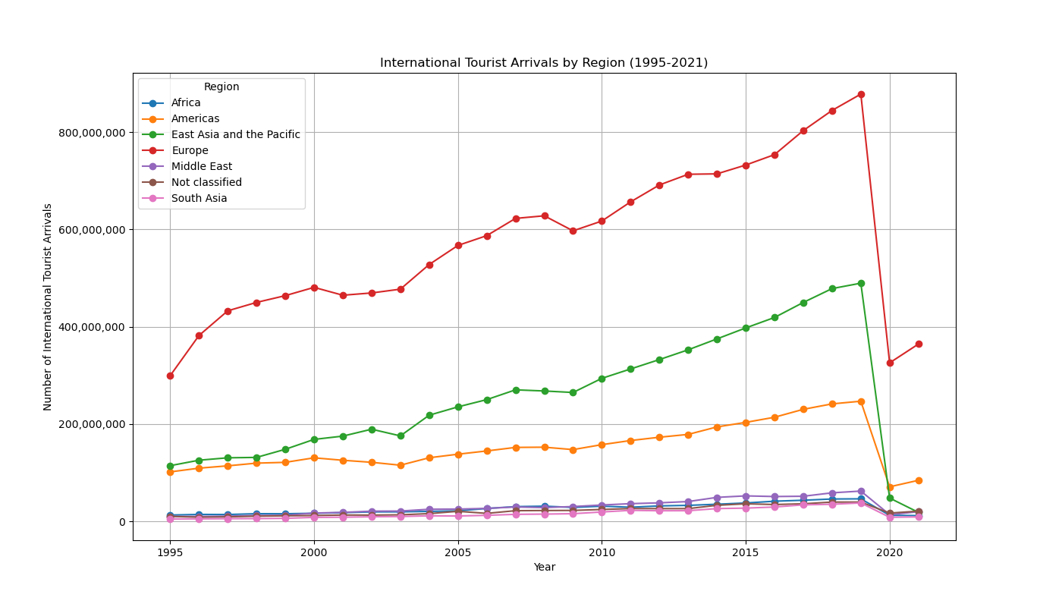

Fig.12 International Tourist Arrivals by Region (1995-2021)

# Discussion

The analysis of mobility patterns and tourism trends over recent years, particularly from 2020 to 2022, underscores the profound impact of the COVID-19 pandemic on global behavior. Figs. 1 through 6 present a detailed comparison of various categories such as grocery & pharmacy, parks, residential, retail & recreation, transit stations, and workplaces. Initially, there were significant declines in categories like transit stations and workplaces due to lockdown measures and the shift to remote work. Conversely, there was an increase in residential stays as people spent more time at home. Retail & recreation activities experienced a steep drop during the initial phase of the pandemic but showed a steady recovery in the subsequent years. These mobility patterns highlight the resilience and adaptability of consumer behavior, with essential services like grocery and pharmacy showing more stability compared to discretionary activities. The gradual recovery observed in 2021 and 2022 reflects the easing of restrictions and a return to more normalized activities, albeit with long-lasting changes in certain sectors such as workplace attendance.

Figs. 7 through 12 extend the discussion to include a comparison of different categories and regions, emphasizing the varying impacts on mobility and international travel. The data reveals that retail & recreation and grocery & pharmacy sectors, while both affected, showed different levels of volatility and recovery. Similarly, parks and residential areas exhibited contrasting patterns, with parks showing significant seasonal fluctuations. The impact on international tourism is vividly illustrated in Fig. 12, where regions like Europe and East Asia, which typically had high tourist arrivals, experienced substantial declines in 2020, reflecting the global travel restrictions. The analysis of these figures provides a comprehensive view of how the pandemic influenced different aspects of consumer behavior and travel, offering valuable insights for future planning and policy-making. The detailed visualizations enable a clear understanding of these trends, highlighting the differential resilience and recovery across sectors and regions. This comprehensive analysis underscores the importance of adaptability and resilience in the face of unprecedented global challenges.

# Conclusions

In conclusion, the extensive analysis of mobility patterns and international tourist arrivals from 2020 to 2022 has unveiled the diverse impacts of the COVID-19 pandemic on global behavior. Initially, significant declines in workplace and transit station usage were observed, while residential stays increased as people adapted to lockdown measures and remote work. Retail & recreation activities faced steep declines, yet they demonstrated a steady recovery in the following years, reflecting consumer resilience and adaptability. Essential services like grocery & pharmacy maintained relative stability, underscoring the consistent demand for essential goods despite the pandemic's challenges. The analysis of international tourism data highlighted a dramatic decrease in travel, especially in high-tourist regions such as Europe and East Asia, with a gradual recovery trend as restrictions eased and travel resumed. These findings emphasize the varying levels of resilience and recovery across different sectors and regions, providing valuable insights for future policy-making and strategic planning. This comprehensive study underscores the importance of adaptability and resilience in the face of global challenges, offering lessons that can help mitigate the impacts of similar events in the future. The detailed visualizations and data interpretations have provided a clear understanding of these trends, essential for informed decision-making moving forward.

##### References

[1] “COVID-19 Community Mobility Reports by Google [USA]”

[Online] Available: <https://www.google.com/covid19/mobility/>

[2] “Globalization, Mobility for Tourism”

[Online] Available: <https://www.kaggle.com/datasets/willianoliveiragibin/globalizationmobility>